**Lesson 5 Demo 2**

**Action Groups**



Steps to be followed:

1. Logging in to the Azure portal at <https://portal.azure.com>
2. Searching for Monitor and selecting it

**Step 1: Logging in to the Azure portal at** [**https://portal.azure.com**](https://portal.azure.com)

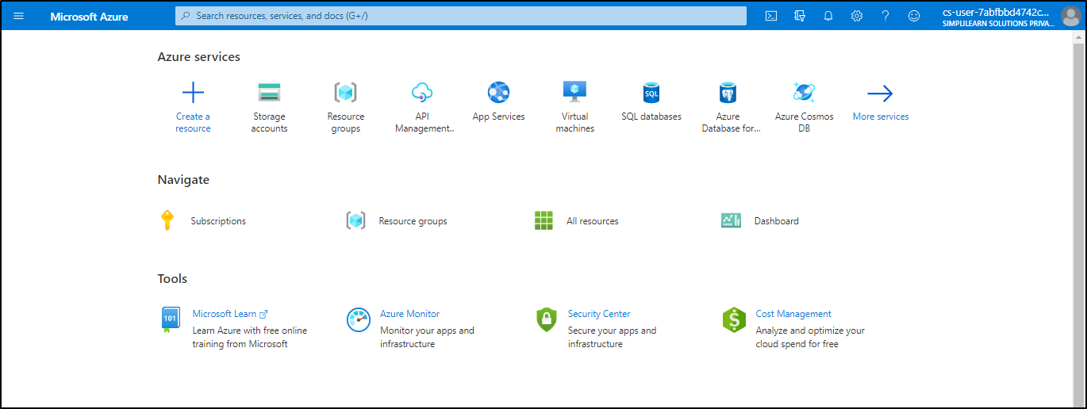

**Step 2: Searching for Monitor and selecting it**

1. In the Azure portal, search for and select **Monitor**. The Monitor pane consolidates all your monitoring settings and data in one view

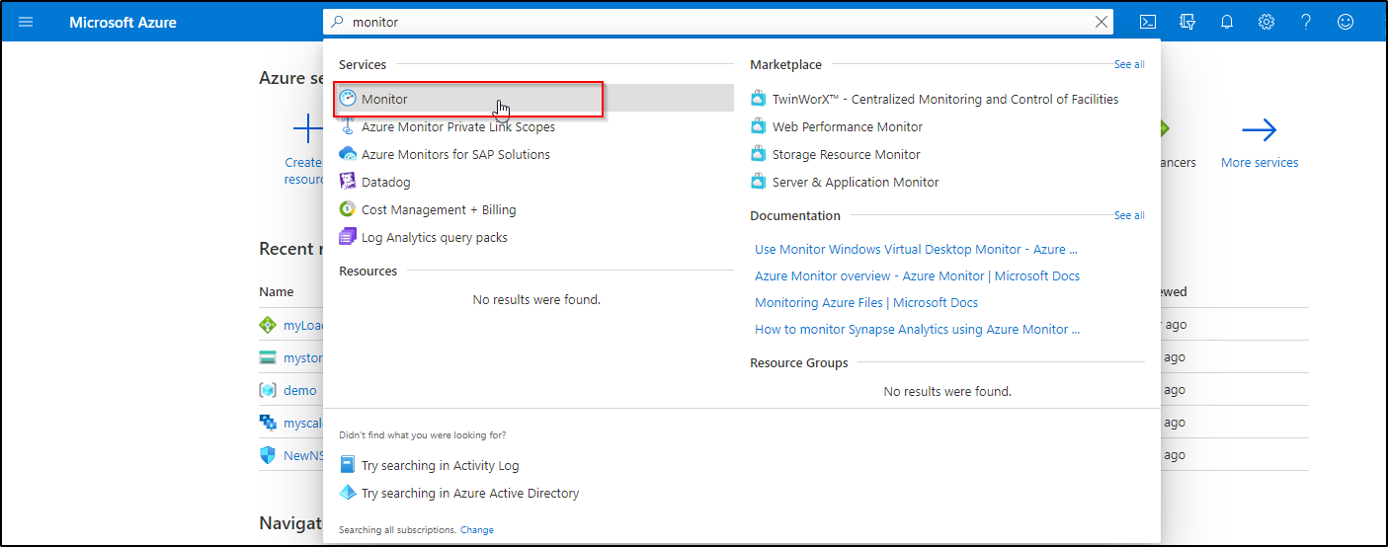

1. Select **Alerts,** then select **Manage actions**

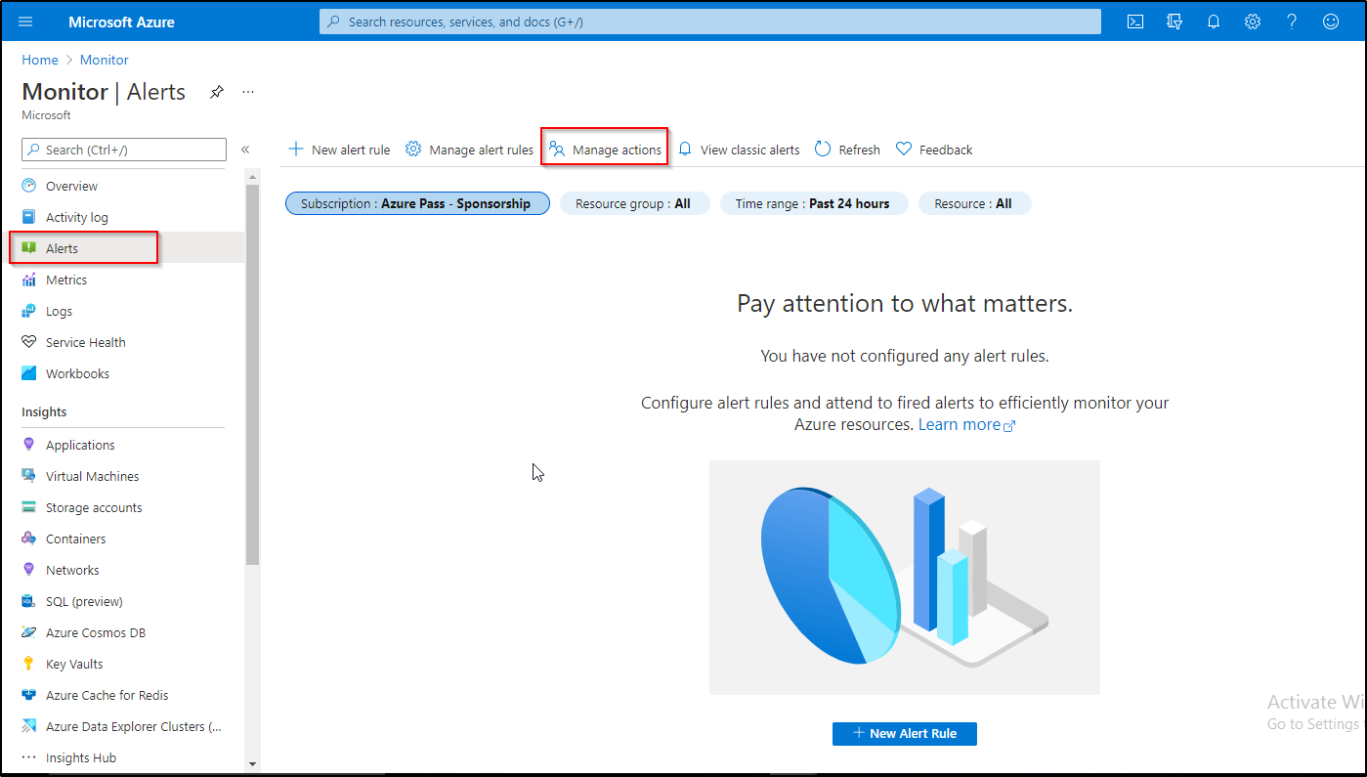

1. Select **Add action group**, and fill in the fields

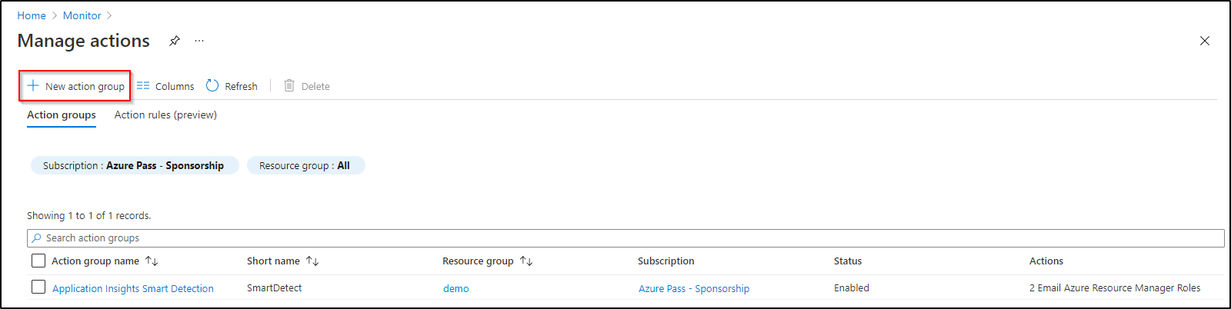

1. Enter a name in the Action group name box, and another name in the **Short name** box. The short name is used in place of a full action group name when notifications are sent using this group
2. The Subscription box auto fills with your current subscription. This subscription is the one in which the action group is saved
3. Select the **Resource group** in which the action group is saved

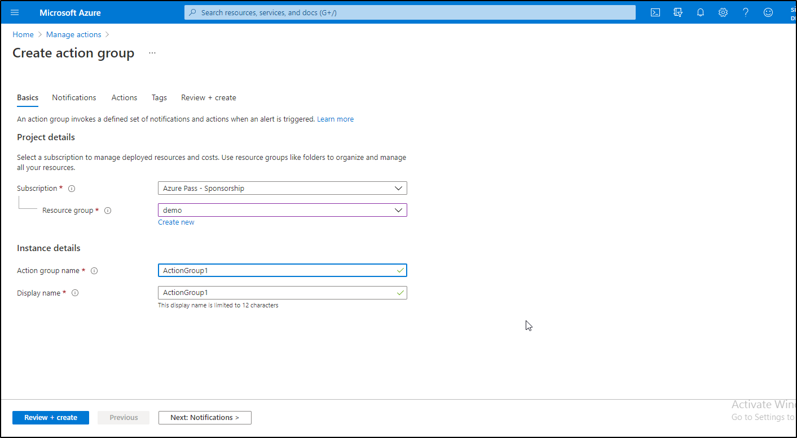

1. Click on **Next: Notifications** and enter the necessary details for alerts

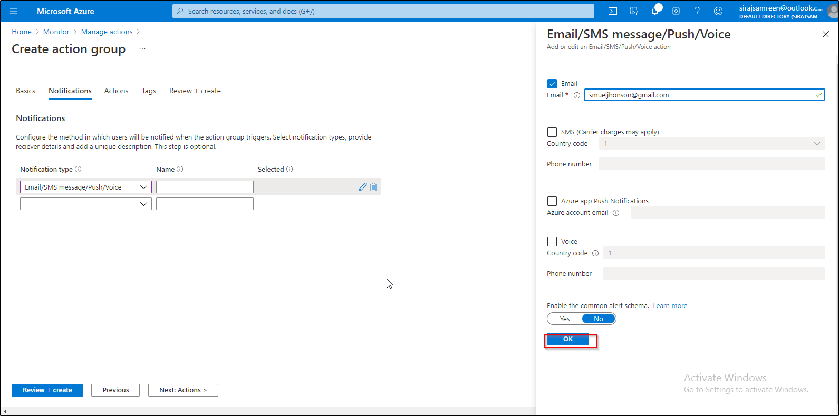

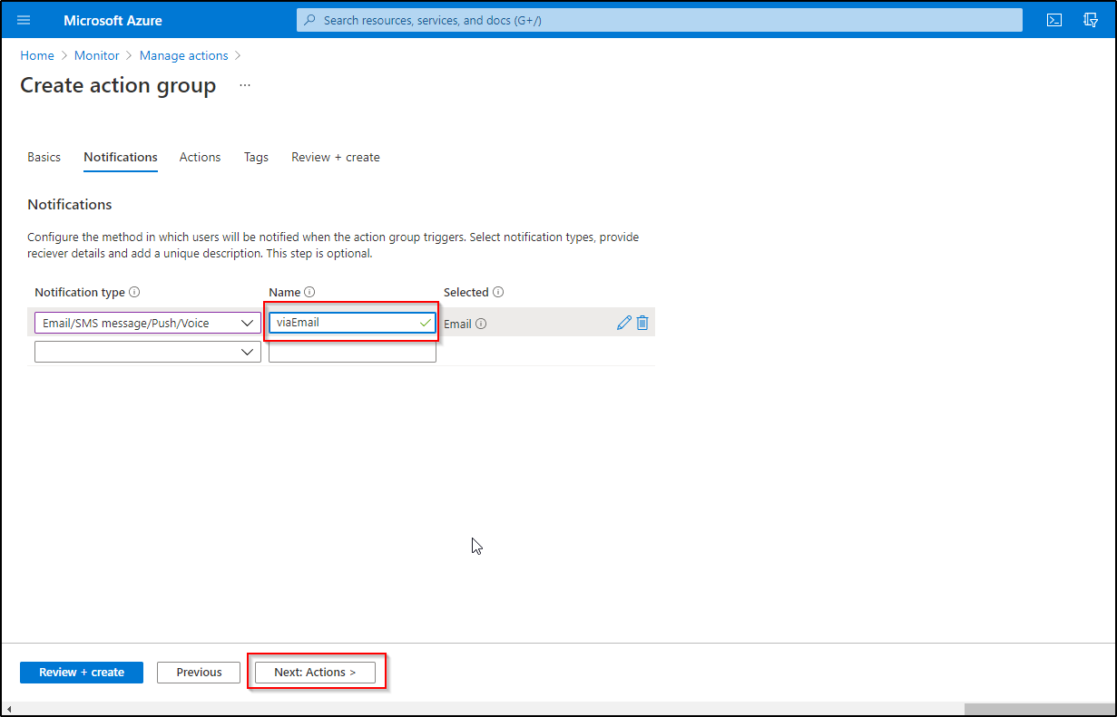

1. Define a list of actions. Provide the following for each action:
2. **Name:** Enter a unique identifier for this action
3. **Action Type:** Select Automation Runbook, Azure Function, Email Azure Resource Manager Role, Email/SMS/Push/Voice, ITSM, Logic App, Secure Webhook, Webhook

**Note:** You must have the item preconfigured before selecting the Action type.

1. **Details:** Based on the action type, enter a phone number, email address, webhook URI, Azure app, ITSM connection, or Automation runbook. For ITSM Action, additionally specify Work Item and other fields your ITSM tool requires
2. **Common alert schema:** You can choose to enable the common alert schema, which provides the advantage of having a single extensible and unified alert payload across all the alert services in Azure Monitor

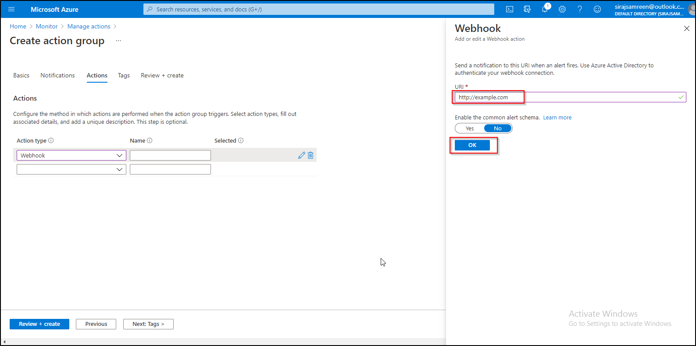

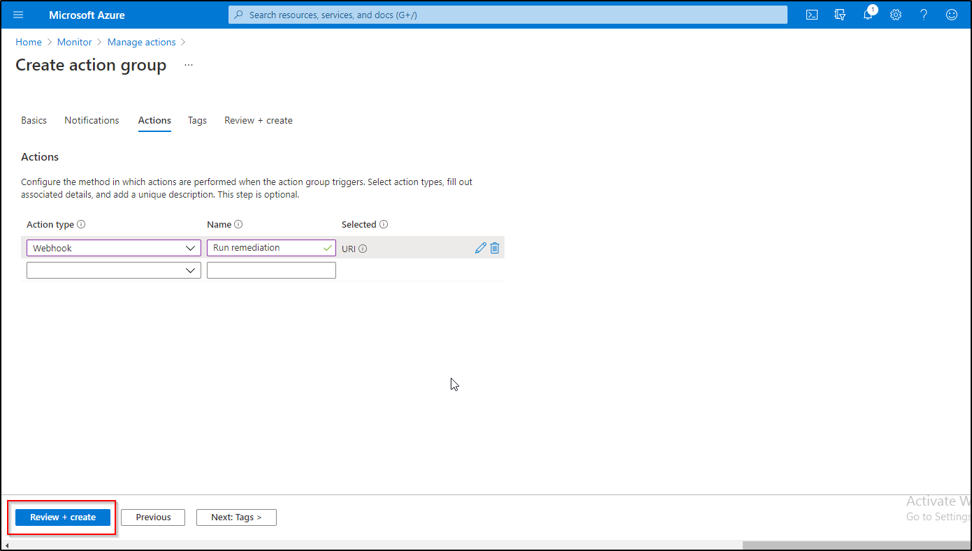

2.9 Click on **Create** to create the action group

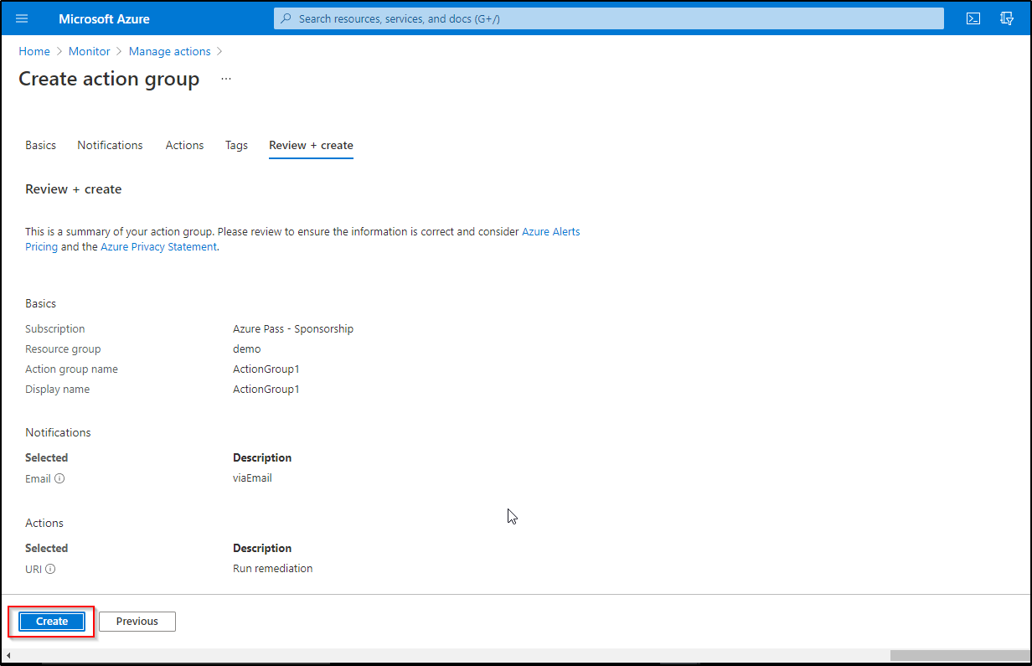

2.10 The action group is created

